SIMATS ENGINEERING (SAVEETHA SCHOOL OF ENGINEERING)
Department of Computer Science and Engineering
CO2 ASSESSMENT TOOL 2 – Architecture Design Assignment

Course Code: | CSA10 / CSA1063 | Course Title: | Software Engineering
CO Assessed: | CO2 | Assessment: | Assessment Tool 2 – Architecture Design Assignment
Weightage: | 20% | Total Marks: | 25
CO2 Statement: | Perform detailed requirements analysis, design scalable architectures, and prioritize features with a focus on cross-disciplinary skills
Student Name: | C.Devasri | Reg. No.: | 192521422
Date: | 26/10/26 | Duration: | 60 minutes

Code of Conduct
I C.Devasri (192521422) certify that this submission is my original work and that I have adhered to the guidelines specified for this assessment. I understand that any violation of academic integrity rules will result in disciplinary action.
Signature of the Student: C.Devasri
Annexure A – Architecture Design Assignment
Instructions to Students:
Each student will be assigned an individual software project problem statement. Based on the assigned problem, analyze the system requirements and design an appropriate software architecture by applying software engineering principles. Your submission should demonstrate your ability to select, justify, and evaluate a suitable architectural style.

Question
Based on your assigned problem statement, perform an Architecture Design Analysis and prepare an architecture design report by answering the following questions:

1. Analyze System Requirements
- Study the given problem statement and identify the system objectives.
- Analyze the functional and non-functional requirements that influence the software architecture.
- Identify key quality attributes such as scalability, maintainability, reliability, availability, performance, and security.

2. Select a Suitable Software Architecture
- Select an appropriate architectural style for the proposed system (e.g., Layered Architecture, Client-Server, MVC, Microservices, Event-Driven, Service-Oriented Architecture, Serverless, or Hybrid Architecture).
- Justify why the selected architecture is the most suitable for the given problem.

3. Draw the Software Architecture Diagram
- Design a clear architecture diagram illustrating the overall structure of the proposed system.
- Include all major layers/components, databases, external systems, APIs, and communication mechanisms.
- Use appropriate software architecture notations and labels.

4. Explain Components and Their Interactions
- Describe the purpose and responsibilities of each architectural component.
- Explain how the components communicate and exchange data.
- Illustrate the overall workflow of the system.

5. Discuss Quality Attributes
Evaluate how the proposed architecture addresses the following aspects:
- Scalability
- Security
- Performance
- Reliability
- Maintainability
- Availability

6. Justify Architectural Decisions
- Explain the rationale behind your architectural choices.
- Discuss the trade-offs considered while selecting the architecture.
- Explain how the chosen architecture supports future enhancements, system integration, and long-term maintainability.

Annexure A – Architecture Design Assignment (Answer)
Assigned Problem Statement No. 8: Privacy-Preserving Smart Campus Digital Twin (PSCDT)
Contents of this report: (1) Analysis of System Requirements; (2) Selection of a Suitable Software Architecture; (3) Software Architecture Diagram; (4) Components and Their Interactions; (5) Quality Attribute Discussion; (6) Justification of Architectural Decisions. Each part ends with or begins with a concept map, and a rubric-mapping table is given at the end.
Summary of the assigned problem statement. Smart campuses use connected systems for buildings, classrooms, energy, transportation, security and student services. Combining these data sources can create a digital representation of campus operations, but excessive collection and centralised processing may introduce privacy, security, scalability and ethical concerns. The platform must integrate selected real-time information from campus facilities and services while minimising exposure of personally identifiable information (PII). It should provide event-driven services, APIs, dashboards, containerised deployment, monitoring and automated delivery, and should apply privacy-aware data processing, access control, audit trails and retention policies while supporting energy optimisation and operational decision-making.

1. Analysis of System Requirements

1.1 System Objectives
The problem statement lists seven objectives. The table shows what each one demands from the software architecture.
ID | Objective | Architectural implication
O1 | Integrate real-time campus facility and service information. | A protocol-diverse ingestion layer (MQTT, REST, batch) feeding an asynchronous, event-driven pipeline.
O2 | Provide digital-twin dashboards for operational monitoring. | A twin-state service with a read-optimised store and push updates (WebSocket) for live dashboards.
O3 | Use a scalable event-driven and API-based architecture. | A message backbone, stateless microservices and an API gateway as the single entry point.
O4 | Minimise collection and exposure of personal information. | A privacy gateway that sanitises data before anything is stored; data catalogue, k-anonymous aggregates and retention jobs.
O5 | Implement access control, audit trails, testing and CI/CD. | SSO and role-based access at the gateway, a separate audit service, containerised services and an automated pipeline.
O6 | Monitor system performance and resource consumption. | An observability stack (metrics, logs, traces, alerts) available to every service.
O7 | Support sustainable campus operations. | An energy-optimisation service that consumes aggregated data; efficient, autoscaled resource use.

Expected outcomes (better visibility, data-driven facility management, less unnecessary personal data, improved energy and resource efficiency, scalable and maintainable services, stronger privacy and security) are achieved when these architectural implications are met together.

1.2 Functional Requirements that Influence the Architecture
Only the functional requirements that shape the structure of the system are listed. The identifiers refer to the requirement specification (FR-nn) prepared in Assessment Tool 1.
Functional area | Key requirements | Architectural influence
Data ingestion and integration (FR-01 – 05) | Continuous data from many sensors and campus systems; validation; device registry. | Asynchronous, broker-based ingestion with pluggable adapters; devices never call internal services directly.
Digital twin and dashboards (FR-06 – 10) | Near real-time state per building and room; history; alerts; role views. | Dedicated twin-state service, cache plus time-series store, WebSocket push, separate read model.
Privacy and data protection (FR-11 – 16) | Remove identifiers, drop unapproved fields, k ≥ 5 aggregation, automated retention. | Privacy gateway as a mandatory, fail-closed pipeline stage placed before the event backbone; policy service.
Access control and audit (FR-17 – 21) | SSO, MFA, RBAC, tamper-evident audit trail. | Central API gateway with OIDC; separate audit service and append-only store.
APIs and events (FR-22 – 24) | Secured REST APIs, OpenAPI docs, event subscriptions. | API gateway with versioned contracts; event topics for subscribers.
Energy and sustainability (FR-25 – 28) | Consumption monitoring, recommendations, approved control. | Separate energy service consuming aggregated events; control commands only through an approval path.
DevOps and monitoring (FR-29 – 34) | Containers, CI/CD, metrics, logs, alerts, automated tests. | Container orchestration, pipeline, observability stack and health endpoints in every service.

1.3 Non-Functional Requirements that Influence the Architecture
Attribute | Requirement / target | Architectural driver
Performance | Event-to-dashboard ≤ 5 s (p95); API ≤ 500 ms; dashboard ≤ 3 s. | Asynchronous pipeline, caching, pre-computed aggregates (read models).
Scalability | 10,000 events/s; 50,000 devices; add capacity with no downtime. | Partitioned topics, stateless services, horizontal autoscaling.
Security and privacy | TLS 1.3, AES-256, MFA, no raw PII after ingestion, DPDP Act 2023 compliance. | Sanitise at the edge, zero-trust service communication, secrets vault, central authentication.
Reliability | No event loss; RPO ≤ 1 h; RTO ≤ 4 h. | Durable broker, replicated stores, idempotent consumers, gateway buffering.
Availability | 99.9% monthly for dashboards and APIs. | Redundant instances across zones, health checks, rolling updates.
Maintainability | Modular design, ≥ 80% test coverage, severity-1 fix in 24 h. | Small independent services, CI/CD, versioned APIs, infrastructure as code.
Interoperability / portability | Open standards; runs on cloud or on-premise. | MQTT, REST/OpenAPI, OIDC and containers; no vendor-specific services in the core.

1.4 Key Quality Attributes and Their Priority
Quality attribute | Why it matters for this system | Priority
Security and privacy | The platform handles data that can reveal where people are; a breach or misuse would break trust and the law. This is the reason the system exists in its “privacy-preserving” form. | 1 – Critical
Scalability | Sensor count and event rate will grow with every new building and data source. | 2 – Very high
Performance | Operators need near real-time information to react to faults and energy waste. | 3 – High
Reliability | Lost or duplicated events would produce wrong dashboards and wrong decisions. | 4 – High
Availability | Campus operations run all day; monitoring and APIs must stay available. | 5 – High
Maintainability | New sources, rules and regulations will change the system for years. | 6 – High

Architecturally significant requirements (ASRs) that decide the design:
- No personal identifier may be stored or passed beyond the ingestion edge (privacy by design, fail-closed).
- The system must absorb 10,000 events per second and grow without redesign (scalability).
- Dashboards must show new data within 5 seconds (performance), so the pipeline must be asynchronous and streaming.
- Every access and change must be authenticated, authorised and recorded (security, audit).
- Services must be built, tested and released automatically and independently (maintainability, CI/CD).
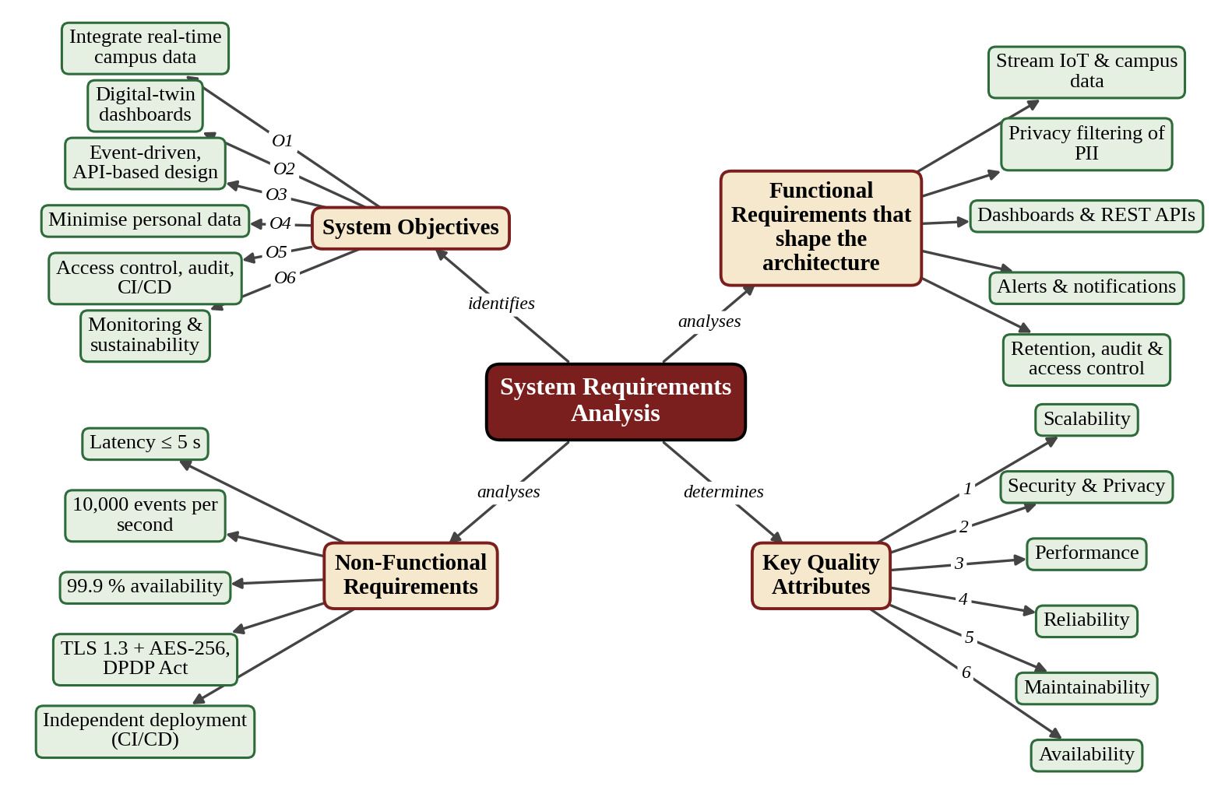

Figure 1: Concept Map – Analysis of System Requirements and Quality Attributes

2. Selection of a Suitable Software Architecture

2.1 Candidate Architectural Styles
Style | Strengths | Limitations for PSCDT | Suitability
Layered | Simple, familiar, clear separation of concerns. | Synchronous and tightly stacked; the whole stack scales together; poor fit for continuous event streams. | Medium (inside services)
Client-Server / MVC | Easy to build web front ends. | Central server becomes bottleneck; does not address streaming IoT data or privacy filtering. | Low (UI only)
Microservices | Independent scaling, deployment and technology choice. | Needs a way to move high-volume data between services; operational overhead. | High
Event-Driven | Loose coupling, buffering, real-time streaming, easy to add consumers. | Eventual consistency; harder to trace flows; needs a good broker. | High
Service-Oriented (SOA) | Reuse of enterprise services. | Heavy central bus and governance; slower change. | Medium
Serverless | Automatic scaling, pay per use. | Limited control over privacy and data location; cold-start delays; vendor lock-in. | Medium
Hybrid: event-driven microservices with layered structure | Combines streaming, independent scaling, strong boundaries and clear layers. | Highest design effort; needs DevOps maturity. | Very high

2.2 Weighted Decision Matrix
Each style is scored from 1 (poor) to 5 (excellent) against criteria taken from the key quality attributes. The weights reflect the priorities in Section 1.4. Weighted score = Σ (weight × score) / 100.
Criteria: C1 Scalability; C2 Security and privacy control; C3 Real-time performance; C4 Reliability and availability; C5 Maintainability and extensibility; C6 Simplicity and cost. The number in brackets is the weight.
Style | C1 (20%) | C2 (20%) | C3 (15%) | C4 (15%) | C5 (15%) | C6 (15%) | Weighted score
Layered | 2 | 3 | 3 | 2 | 3 | 5 | 2.95
Client-Server / MVC | 2 | 3 | 3 | 2 | 3 | 5 | 2.95
Microservices only | 5 | 4 | 3 | 4 | 5 | 2 | 3.90
Event-Driven only | 5 | 3 | 5 | 4 | 3 | 3 | 3.85
SOA | 3 | 4 | 3 | 3 | 3 | 2 | 3.05
Serverless | 4 | 3 | 3 | 4 | 3 | 3 | 3.35
Hybrid (selected) | 5 | 5 | 5 | 5 | 5 | 3 | 4.70

The hybrid architecture scores highest (4.70 out of 5). It loses points only on simplicity, which is accepted because the other five criteria, which carry 85% of the weight, are the ones the problem statement emphasises.

2.3 Selected Architecture
Selected style: Hybrid Architecture – Event-Driven Microservices with a layered structure, an API Gateway and a Privacy Gateway at the edge.
Pattern / style | Where it is applied | Purpose
Event-driven (publish / subscribe) | Event backbone between ingestion and all domain services. | Real-time streaming, buffering, loose coupling, easy addition of consumers.
Microservices | Twin state, aggregation, alert rules, energy, retention, audit, notification, device registry. | Independent scaling, deployment and fault isolation.
Layered | Overall flow (sources → edge → backbone → services → data → gateway → presentation) and inside each service (API, business logic, data access). | Separation of concerns; clear dependency direction.
Pipes and filters / privacy gateway | Edge pipeline: gateway → validation → privacy filter. | Guarantees that every event is sanitised before it enters the system.
API Gateway | Single entry point for dashboards and applications. | Authentication, authorisation, rate limiting, routing, versioning.
Database per service / polyglot persistence | Time-series DB, twin-state cache, relational DB, append-only audit store. | Each service uses the store that suits its data; no shared-database coupling.
CQRS-style read models | Pre-computed aggregates for dashboards. | Fast reads without loading the ingestion path.

2.4 Why this Architecture is the Most Suitable
Requirement / driver | How the selected architecture satisfies it
Continuous, high-volume IoT data (O1, O3) | The event backbone absorbs bursts, decouples producers from consumers and lets many services process the same stream.
Privacy by design (O4) | The privacy gateway is a mandatory stage before the backbone, so raw identifiers are never stored or distributed. Only anonymised, aggregated data exists downstream.
Scalability (NFR-03) | Topics are partitioned and services are stateless, so each service scales by adding instances.
Real-time dashboards (O2, NFR-01) | Events are processed as a stream; the twin-state service updates a cache and pushes changes to the browser.
Security, access control and audit (O5) | All external access passes through one gateway with SSO and RBAC; the audit service records every action in an append-only store.
Integration of new sources and apps (O1, O3) | New adapters publish to existing topics, and new services subscribe without changing existing ones.
Continuous delivery and monitoring (O5, O6) | Small containerised services can be built, tested and deployed independently; every service exposes metrics and health checks.
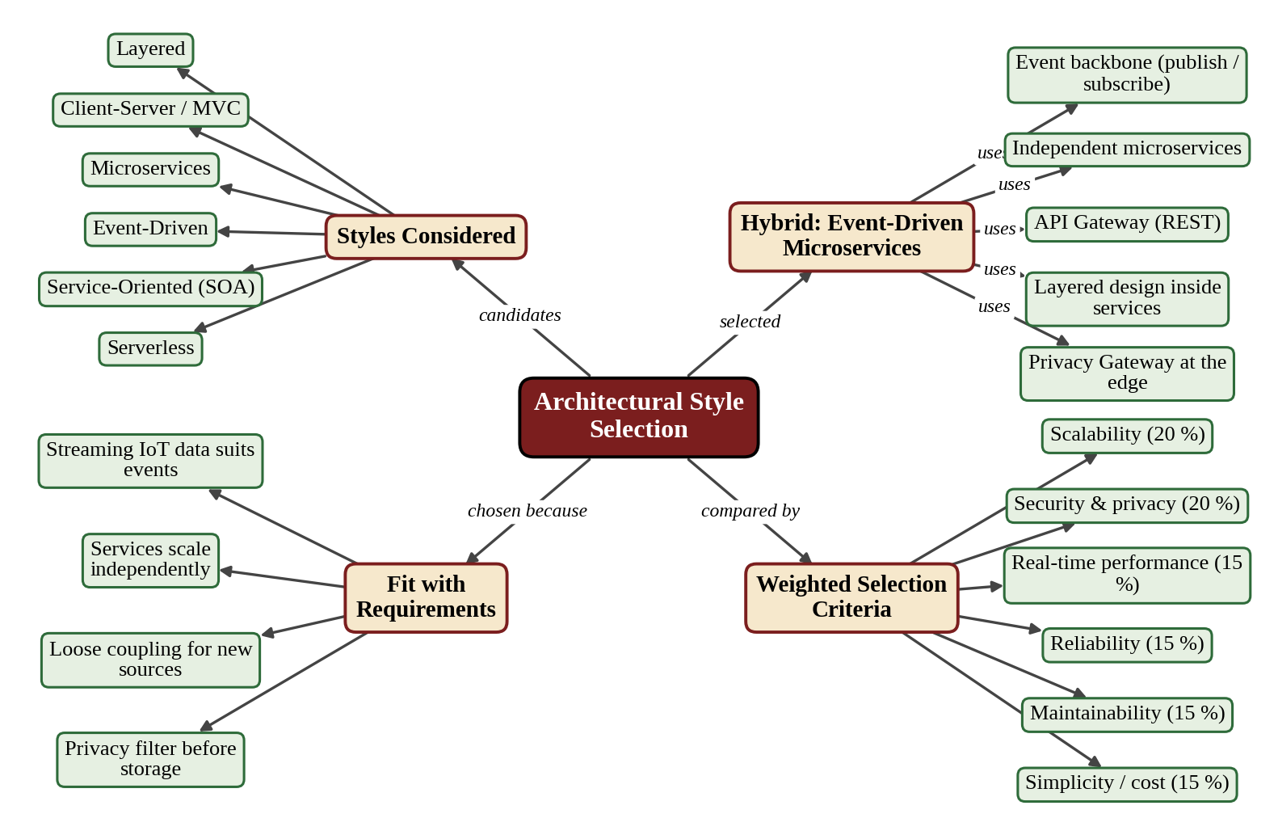

Figure 2: Concept Map – Selection of the Software Architecture

3. Software Architecture Diagram

3.1 Logical Architecture Diagram
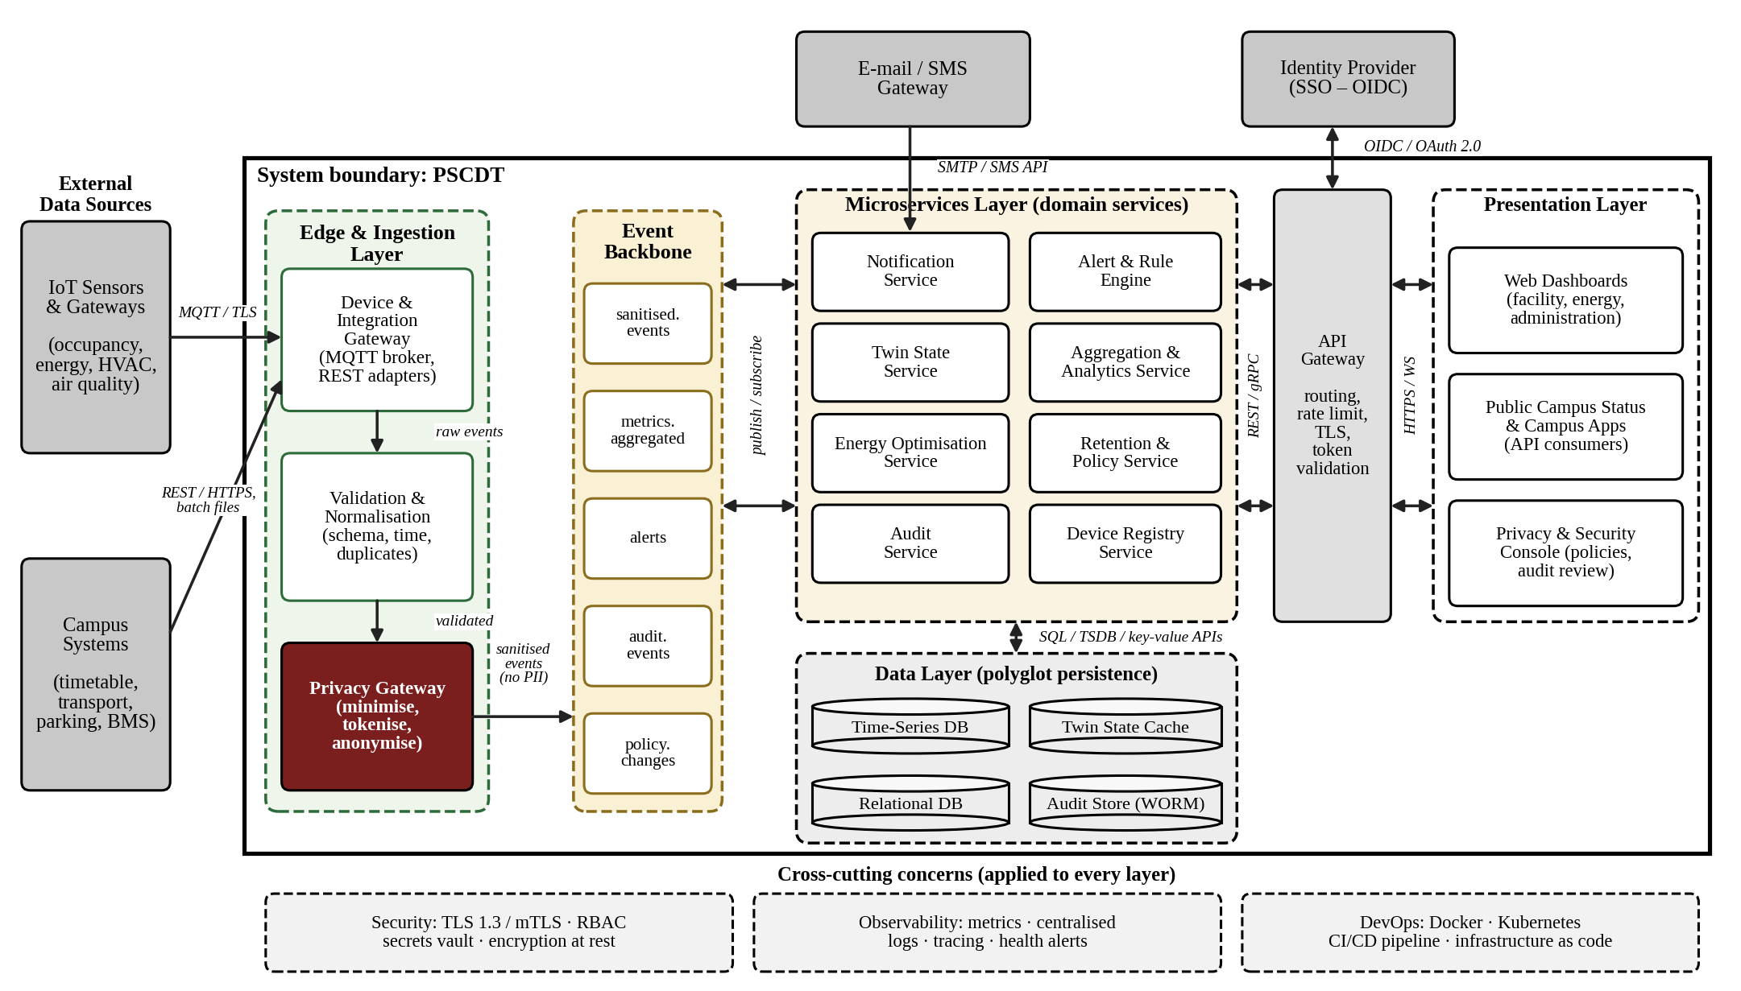

Figure 3: Logical Architecture of the Privacy-Preserving Smart Campus Digital Twin
Notation: solid boxes = components; dashed frames = layers / trust zones; cylinders = data stores; grey boxes = external systems; dark red box = privacy gateway; arrows = data flow, with the protocol written on each link (double-headed arrow = two-way).

3.2 Layers, Components and Interfaces
Layer | Components | Interfaces / protocols
External data sources | IoT sensors and gateways; campus systems (BMS, timetable, transport, parking). | MQTT over TLS; REST / HTTPS; batch files.
Edge and ingestion | Device and Integration Gateway; Validation and Normalisation; Privacy Gateway. | Receives raw data; emits sanitised events only.
Event backbone | Event streaming platform with topics: sanitised.events, metrics.aggregated, alerts, audit.events, policy.changes. | Publish / subscribe over TLS; at-least-once delivery.
Microservices | Notification, Alert and Rule Engine, Twin State, Aggregation and Analytics, Energy Optimisation, Retention and Policy, Audit, Device Registry. | Events from the backbone; REST / gRPC to the API gateway.
Data layer | Time-series DB, twin-state cache, relational DB, append-only audit store. | SQL, time-series and key-value APIs (service-owned).
API gateway and presentation | API Gateway; web dashboards; public status page and campus apps; privacy and security console. | HTTPS, WebSocket, OpenAPI REST; OIDC / OAuth 2.0 with the Identity Provider.
External services | Identity Provider (SSO); e-mail / SMS gateway. | OIDC; SMTP / SMS API.
Cross-cutting | Security (TLS, RBAC, vault), observability (metrics, logs, traces), DevOps (containers, CI/CD). | Applied to every layer.

3.3 Deployment View
The logical components are packaged as containers and run on a container-orchestration platform across two availability zones. An automated CI/CD pipeline builds, tests, scans and deploys every change. This view shows how the architecture meets availability, scalability and maintainability in practice.
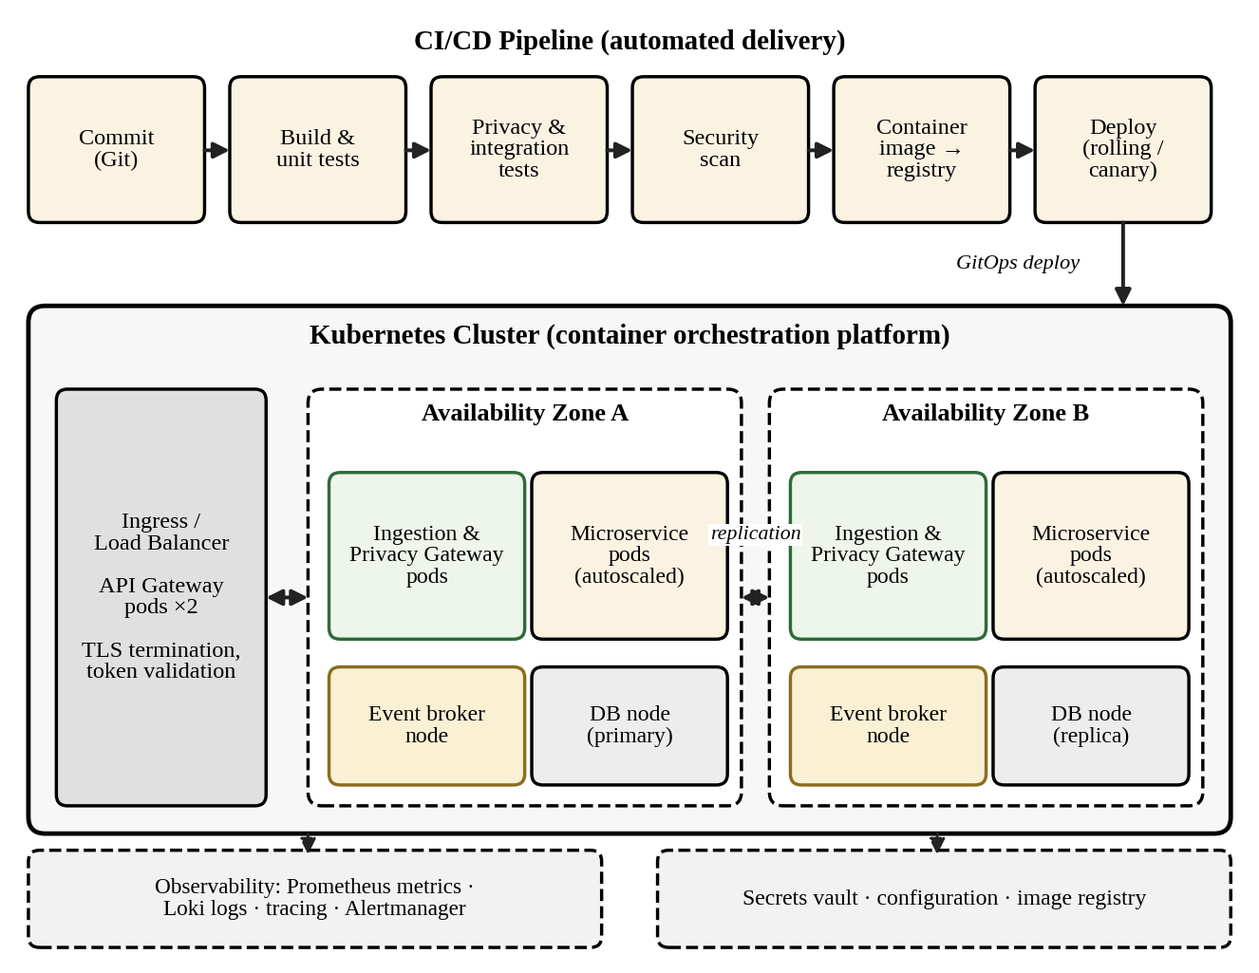
Figure 4: Deployment View – CI/CD Pipeline and Container Platform
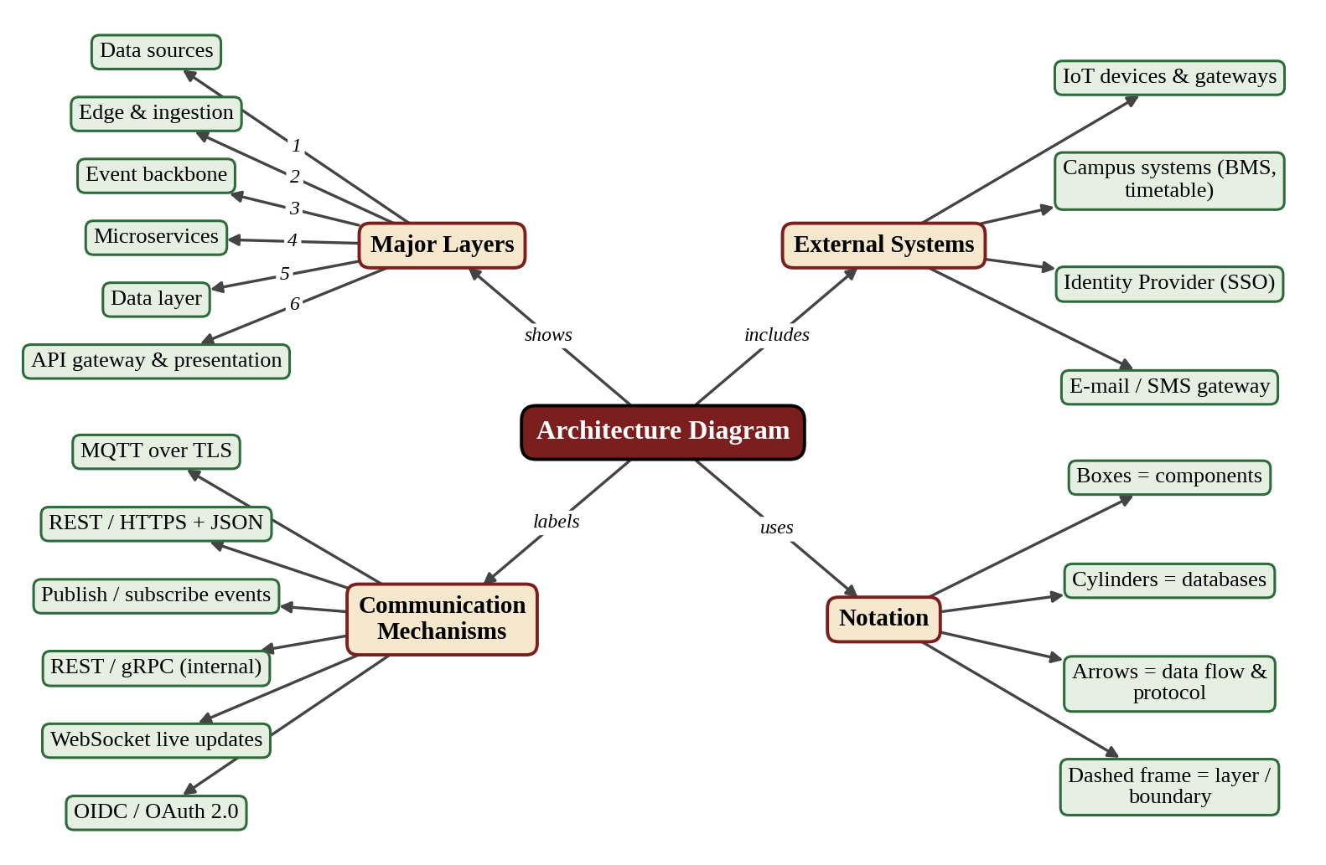
Figure 5: Concept Map – Architecture Diagram Elements

4. Components and Their Interactions

4.1 Purpose and Responsibilities of Each Component
Component | Purpose | Key responsibilities | Example technology
Edge and ingestion
Device and Integration Gateway | Single door for all incoming data. | Authenticate devices (certificate / token); accept MQTT, REST and batch; buffer during outages; route messages. | MQTT broker, REST adapters
Validation and Normalisation | Make data uniform and trustworthy. | Check schema and timestamp; remove duplicates; convert to a common model; quarantine bad events. | Stream processor
Privacy Gateway | Enforce privacy by design. | Drop unapproved fields; hash or tokenise identifiers; generalise location and time; fail-closed if rules cannot run. | Rule-based filter service
Event backbone
Event Streaming Platform | Decouple producers and consumers. | Durable, partitioned topics; replay; at-least-once delivery; dead-letter queue. | Kafka-class broker
Microservices
Twin State Service | Hold the live model of the campus. | Update room / building state from events; serve current and historical state. | Containerised service + cache
Aggregation and Analytics Service | Create privacy-safe metrics. | Compute zone-level aggregates; enforce k ≥ 5; publish metrics. | Stream analytics
Alert and Rule Engine | Detect conditions worth acting on. | Evaluate thresholds and rules; publish alerts. | Rules engine
Energy Optimisation Service | Support sustainability. | Combine occupancy, timetable and consumption; produce recommendations and KPIs. | Analytics service
Retention and Policy Service | Apply data-protection policy. | Hold the data catalogue; push policy changes; delete or aggregate expired data. | Scheduler + policy store
Audit Service | Provide accountability. | Record logins, accesses and changes in a hash-chained, append-only log. | Append-only store
Device Registry Service | Know every device. | Register, update and deactivate devices; track health and last-seen. | Relational DB
Notification Service | Reach people. | Send e-mail / SMS / dashboard alerts when alerts are published. | SMTP / SMS client
Data layer
Time-series DB, Twin State Cache, Relational DB, Audit Store | Store data suited to each service. | Metrics history; fast current state; configuration, catalogue, users; immutable audit records. | Time-series DB, in-memory cache, SQL DB
Access layer and cross-cutting
API Gateway | Controlled entry point. | Validate tokens; enforce RBAC and rate limits; route to services; version APIs. | API gateway
Web Dashboards / Console / Apps | Present information. | Role-specific dashboards, public status, privacy and administration console. | Web application
Identity Provider | Authenticate users. | SSO and MFA; issue tokens (OIDC). | OIDC provider
Observability and CI/CD | Operate and deliver safely. | Collect metrics, logs and traces; alert DevOps; build, test, scan and deploy containers. | Prometheus, Loki, CI server, Kubernetes

4.2 Communication and Data Exchange
From → To | Mechanism | Data exchanged | Style
IoT devices → Gateway | MQTT over TLS | Raw readings (device ID, time, value). | Asynchronous
Campus systems → Gateway | REST / HTTPS, batch files | Timetable, transport, BMS data. | Sync / batch
Gateway → Validation → Privacy Gateway | Internal stream (in memory) | Raw then validated events; never persisted. | Asynchronous
Privacy Gateway → Backbone | Publish over TLS | Sanitised events with no personal identifiers. | Asynchronous
Backbone ↔ Microservices | Publish / subscribe | Events, aggregated metrics, alerts, audit and policy events. | Asynchronous
Microservices ↔ Data layer | SQL / time-series / key-value APIs | Metrics, twin state, configuration, audit records. | Synchronous
API Gateway ↔ Microservices | REST / gRPC over mTLS | Queries for twin state, analytics, administration. | Synchronous
Presentation ↔ API Gateway | HTTPS, WebSocket | Requests, JSON responses, live updates. | Sync + streaming
API Gateway ↔ Identity Provider | OIDC / OAuth 2.0 | Authentication, tokens, roles. | Synchronous
Notification Service → E-mail / SMS | SMTP / SMS API | Alert messages. | Asynchronous

4.3 Overall Workflow of the System
The system has three cooperating flows, shown in Figure 6:
- Data / event path (steps 1 – 8): a reading is received, validated, sanitised by the Privacy Gateway, published to the backbone, consumed by the twin, aggregation and alert services, stored, and – if a threshold is breached – turned into a notification.
- Governance and operations path (steps 9 – 14): policy changes are published and applied by the services; the audit service records events; retention jobs delete expired data; monitoring and CI/CD keep the platform healthy and up to date.
- User / API path (steps 15 – 21): a user authenticates through SSO, the API gateway checks the token and role, the request is routed to a service that reads anonymised data, and the access is audited.
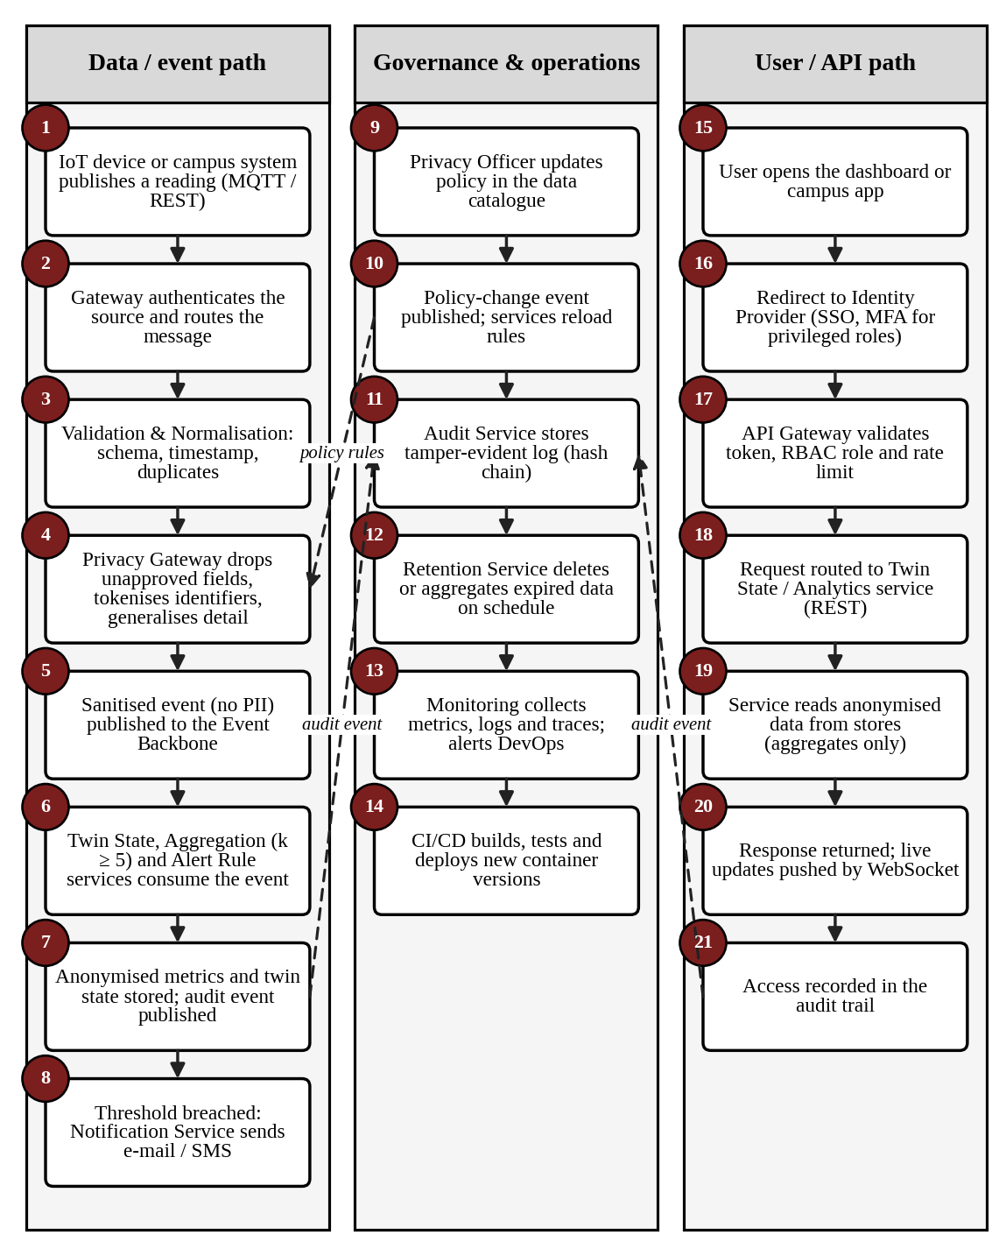
Figure 6: End-to-End Workflow of the Smart Campus Digital Twin

4.4 Example of the Privacy Transformation
The table shows what the Privacy Gateway does to one reading, which is the central design feature of the system.
Step | Data before the Privacy Gateway | Data after the Privacy Gateway
Device identifier | Wi-Fi MAC address of a phone. | Removed, or replaced by a salted hash that changes daily.
Location | Room B2-204. | Zone B2-Floor 2-West.
Time | 10:15:32. | 10:15 (one-minute window).
Number of people | One device = one person. | Zone count; published only if the group is at least 5.
Unapproved fields | Device name, user agent. | Dropped (not in the data catalogue).
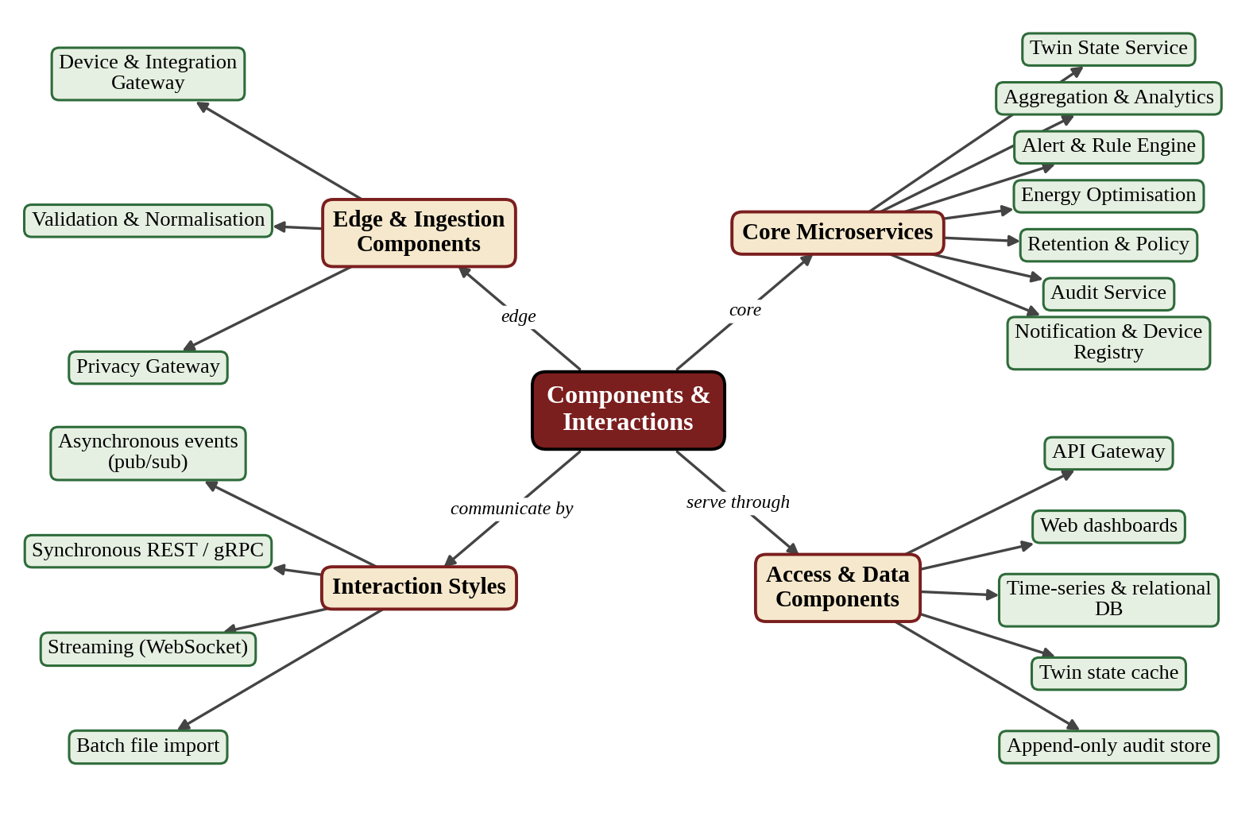
Figure 7: Concept Map – Components and Their Interactions

5. Discussion of Quality Attributes
Each attribute below is evaluated against the proposed architecture: what is the concern, which architectural tactics address it, and how the result is measured.

5.1 Scalability
Sensor count and event volume will keep growing. The architecture scales horizontally because producers and consumers are decoupled and services hold no local state.
- Partitioned topics let many consumer instances share the load (target 10,000 events/s, 50,000 devices).
- Stateless microservices are autoscaled by the orchestrator when CPU or event lag rises.
- Each data store scales independently (time-series for history, cache for current state).
- New data sources are added as adapters; no change is needed in existing services.

5.2 Security
The system must protect people’s privacy and the campus infrastructure. Security is built in at several layers instead of added at the end.
- Privacy gateway sanitises data at the edge; raw identifiers never reach storage or the backbone.
- TLS 1.3 for all external traffic and mTLS between services; AES-256 for stored data; secrets kept in a vault.
- SSO with MFA for privileged roles; RBAC enforced at the API gateway and again inside services.
- Tamper-evident, append-only audit trail; network segmentation and least-privilege access.

5.3 Performance
Dashboards must show data within 5 seconds and APIs must answer within 500 ms. The streaming design avoids waiting on slow database writes.
- Asynchronous event processing; the user never waits for ingestion.
- Twin state kept in an in-memory cache and updates pushed through WebSocket.
- Pre-computed aggregates (read models) for dashboards and reports.
- Time-series database tuned for write-heavy workloads; API gateway rate limiting protects services.

5.4 Reliability
A wrong or lost event would give wrong decisions. The architecture accepts that failures happen and designs for recovery.
- Durable, replicated broker with at-least-once delivery and idempotent consumers (no double counting).
- Gateway buffers events locally during a broker outage and replays them afterwards.
- Retry with back-off and a dead-letter queue for events that cannot be processed.
- Daily backups with RPO ≤ 1 hour and RTO ≤ 4 hours; schema validation protects data quality.

5.5 Maintainability
Rules, regulations and data sources will change over the years. The architecture keeps change local and cheap.
- Small services with single responsibility and clear boundaries; changes affect one service.
- Versioned OpenAPI contracts and event schemas allow independent releases.
- CI/CD with unit, integration, security and privacy tests (≥ 80% coverage); infrastructure as code.
- Common logging, metrics and tracing make faults quick to find; architectural decisions are documented.

5.6 Availability
Dashboards and APIs must be available around the clock (99.9% monthly, about 43 minutes of downtime).
- Multiple replicas of every service and of the gateway across two availability zones.
- Load balancer with health checks and automatic restart of failed containers (self-healing).
- Rolling and canary deployments, so releases cause no downtime.
- Graceful degradation: dashboards keep showing the last known state if a back-end service is temporarily down.

5.7 Quality Attribute Scenarios
Attribute | Scenario (stimulus → response) | Response measure
Scalability | Two new buildings add 20,000 sensors → new consumer instances start automatically. | Throughput 10,000 events/s sustained with no code change or downtime.
Security | A new data source sends a Wi-Fi MAC address → Privacy Gateway removes or hashes it before storage. | 0 raw identifiers found in storage or topics; event counted in the privacy log.
Performance | A temperature sensor value changes → dashboard updates. | ≤ 5 s end-to-end at the 95th percentile.
Reliability | The broker node fails during ingestion → gateway buffers and replays. | 0 lost events; recovery ≤ 5 min.
Maintainability | A new alert rule type is needed → only the Alert and Rule Engine changes. | Change delivered by the pipeline in one working day without touching other services.
Availability | One availability zone becomes unreachable → traffic moves to the other zone. | Dashboards and APIs stay available; monthly availability ≥ 99.9%.
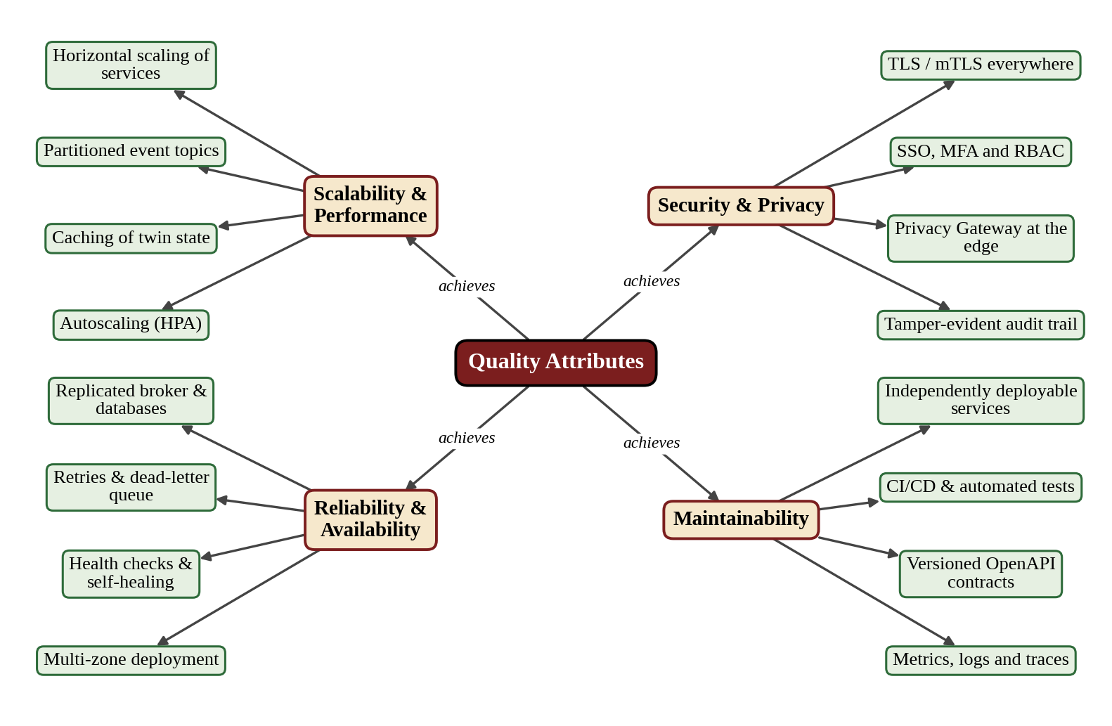

Figure 8: Concept Map – Quality Attributes and Tactics

6. Justification of Architectural Decisions
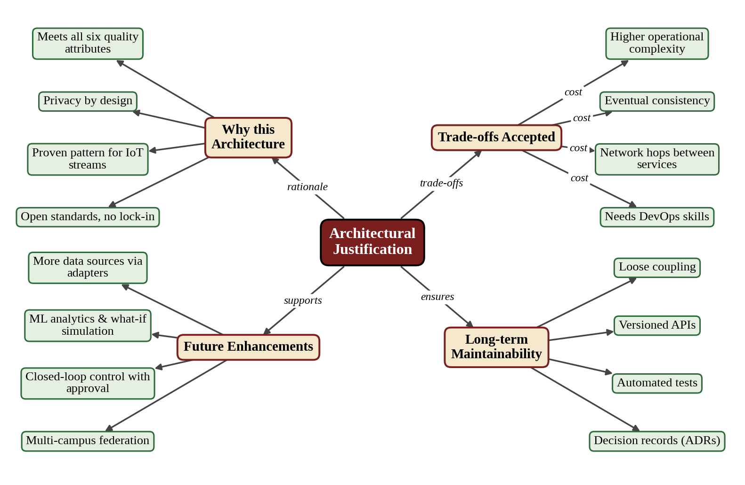
Figure 9: Concept Map – Architectural Justification, Trade-offs and Future Scope

6.1 Rationale for the Main Decisions
ID | Decision | Alternatives considered | Rationale
AD-1 | Hybrid event-driven microservices. | Layered monolith, SOA, serverless. | Only this combination meets scalability, real-time performance and independent change together (Section 2.2).
AD-2 | Privacy Gateway at the edge, before the event backbone, fail-closed. | Central processing of raw data; filtering at the dashboard. | Removes the single largest risk: raw personal data in a central store. Objective O4 is enforced by structure, not by policy alone.
AD-3 | Event streaming platform with partitioned topics and at-least-once delivery. | Direct service-to-service calls; database polling. | Handles bursts, allows replay and decouples services; idempotent consumers remove duplicate risk.
AD-4 | Database per service with polyglot persistence. | One shared relational database. | Each service uses a suitable store; no shared-schema coupling; audit data can be append-only.
AD-5 | API Gateway with OIDC SSO and RBAC. | Authentication inside every service. | One enforcement point; consistent rate limiting, logging and versioning.
AD-6 | Containers on Kubernetes with CI/CD. | Virtual machines with manual releases. | Fast, repeatable, automated delivery; autoscaling and self-healing.
AD-7 | Open standards (MQTT, REST/OpenAPI, OIDC). | Vendor-specific platform services. | Avoids lock-in; easy integration with devices and campus systems.
AD-8 | Read models for dashboards (CQRS style). | Query raw event store directly. | Fast dashboards and privacy-safe aggregates, without loading the ingestion path.

6.2 Trade-offs Considered
Trade-off | Benefit gained | Cost accepted | Mitigation
Microservices vs simple monolith | Independent scaling, release and fault isolation. | More components and network calls; operational complexity. | Orchestration platform, shared templates, central observability.
Event-driven vs request / response | Throughput, resilience, loose coupling. | Eventual consistency; harder tracing. | Correlation IDs, distributed tracing, idempotent consumers.
Fail-closed privacy vs availability | No personal data can leak if the filter fails. | Events are held back during a filter failure. | Redundant filter instances; gateway buffering and replay.
Polyglot storage vs one database | Right store for each need. | More technologies to operate. | Managed or containerised stores; standard backup procedure.
Aggregation (k ≥ 5) vs detail | Individuals cannot be singled out. | Less detail for very small groups. | Rooms show only occupied / vacant; detail kept for non-personal sensors.
Open source vs commercial platform | No lock-in; low licence cost. | Needs in-house skills. | Training; well-supported mainstream tools.

6.3 Support for Future Enhancements, Integration and Long-Term Maintainability

Future enhancements
- Machine-learning services (occupancy forecasting, fault prediction) subscribe to existing aggregated topics without changing ingestion.
- What-if simulation on the digital twin and closed-loop energy control with human approval can be added as new services.
- Additional buildings, campuses or a multi-campus federation are added by deploying more adapters and scaling the same components.

System integration
- Adapters isolate each external system; replacing a timetable or transport system affects only its adapter.
- Versioned OpenAPI REST APIs and event schemas let new campus apps and partners integrate safely.
- Standards-based interfaces (MQTT, OIDC, REST/JSON, smart-city data models) make integration with future devices and platforms easy.

Long-term maintainability
- Loose coupling and clear service boundaries keep the cost of change low and let teams work in parallel.
- Automated tests (including privacy tests) and CI/CD make frequent, safe releases routine.
- Architecture decision records, API documentation and observability make the system understandable to new team members.

6.4 Conclusion
The hybrid architecture of event-driven microservices, a layered structure, an API gateway and an edge privacy gateway fits the Privacy-Preserving Smart Campus Digital Twin better than any single style. It makes privacy a structural property of the system, scales with the number of sensors, delivers real-time dashboards, protects access with SSO, role-based control and audit trails, and can be built, monitored and changed continuously. The trade-offs, mainly operational complexity and eventual consistency, are known and have practical mitigations.

6.5 Mapping of this Report to the Evaluation Rubrics
Rubric criterion (weight) | Evidence in this report | Section
System Requirement Analysis (30%) | Objectives, functional and non-functional requirements, quality attributes with priorities, ASRs, concept map | 1; Fig. 1
Selection of Software Architecture (25%) | Seven styles compared, weighted decision matrix, hybrid style with patterns, requirement-wise justification | 2; Fig. 2
Architecture Diagram and Component Design (20%) | Layered logical diagram with protocols, external systems and data stores; deployment view; layer table | 3; Figs. 3–5
Component Interaction and Quality Attribute Analysis (15%) | Component responsibilities, communication table, workflow diagram, six quality attributes with tactics and scenarios | 4, 5; Figs. 6–8
Architectural Justification and Technical Presentation (10%) | Decision records, trade-offs with mitigation, future enhancements, integration, maintainability, organised report | 6; Fig. 9

Rubrics for Calculation
Evaluation Criteria | Excellent (4 Marks) | Good (3 Marks) | Satisfactory (2 Marks) | Needs Improvement (1 Mark)
System Requirement Analysis (30%) | Thoroughly analyzes the problem statement, accurately identifies functional and non-functional requirements, and clearly explains quality attributes influencing the architecture. | Analyzes most requirements with minor omissions or limited explanation. | Identifies only basic requirements with partial analysis. | Requirement analysis is incomplete, inaccurate, or lacks clarity.
Selection of Software Architecture (25%) | Selects the most appropriate architectural style with strong technical justification aligned to system requirements. | Selects a suitable architecture with reasonable justification. | Architecture is partially suitable with limited justification. | Inappropriate architecture selected or justification is missing.
Architecture Diagram and Component Design (20%) | Produces a clear, complete, and well-structured architecture diagram with all major components, interfaces, and interactions accurately represented. | Diagram is mostly complete with minor omissions or notation issues. | Diagram includes only essential components and lacks sufficient detail. | Diagram is incomplete, unclear, or technically incorrect.
Component Interaction and Quality Attribute Analysis (15%) | Clearly explains component responsibilities, interactions, and thoroughly discusses scalability, security, performance, reliability, maintainability, and availability. | Explains most components and quality attributes with minor gaps. | Provides limited explanation of interactions and addresses only some quality attributes. | Component interactions and quality attributes are poorly explained or missing.
Architectural Justification and Technical Presentation (10%) | Provides strong justification for architectural decisions, discusses trade-offs and future enhancements, and presents a well-organized, professional report. | Provides adequate justification with minor gaps; report is well organized. | Limited justification with minimal discussion of trade-offs or future scope; report needs improvement. | Justification is weak or absent; report lacks organization and technical clarity.

Criteria | Mark
System Requirement Analysis (30%) | /5
Selection of Software Architecture (25%) | /5
Architecture Diagram and Component Design (20%) | /5
Component Interaction and Quality Attribute Analysis (15%) | /5
Architectural Justification and Technical Presentation (10%) | /5
TOTAL | /25

